NAME Date/Time

GUERILLA RGCL Usability Test

INTRO:

· THANK YOU for participating in our Usability Session. Introduce all people …
In this study we are testing a design. We want to make it as easy to use as possible before we release it. Its NOT a TEST OF YOUR SKILLS but DESIGN.

· Work in progress: During the study I will show you some pictures of the design mockups and some interactive partially built parts.

· BEHAVE Naturally – Try behaving as if you were at home with no one watching.

· BE HONEST: We are looking for your help to tell us if anything is confusing or unclear. Please tell us exactly what you think, don’t just be polite?

· THINK ALOUD: While you are using this app, can you please think aloud so we can understand what you are trying to do, what you are seeing, if anything is clear or unclear.

BACKGROUND:

Sports Fan? Yes/ No
Yes Which sport &
Yes How long weekly watching time? hrs/wk
Device for sport viewing TV / PC / Tablet / Phone / Other
Cable TV customer? Y/N
Rogers TV Y/N

BUY ONLINE Y / N
Yes When last?
Yes What?

OPTIONAL:

At the END: GCL Subscriber / Familiar Heard of it / Not heard of it

Gender Age Name?

CASE A - BUY FLOW - CC PAYMENT

5 Second Test …

- What do you remember seeing on the page?

HOME
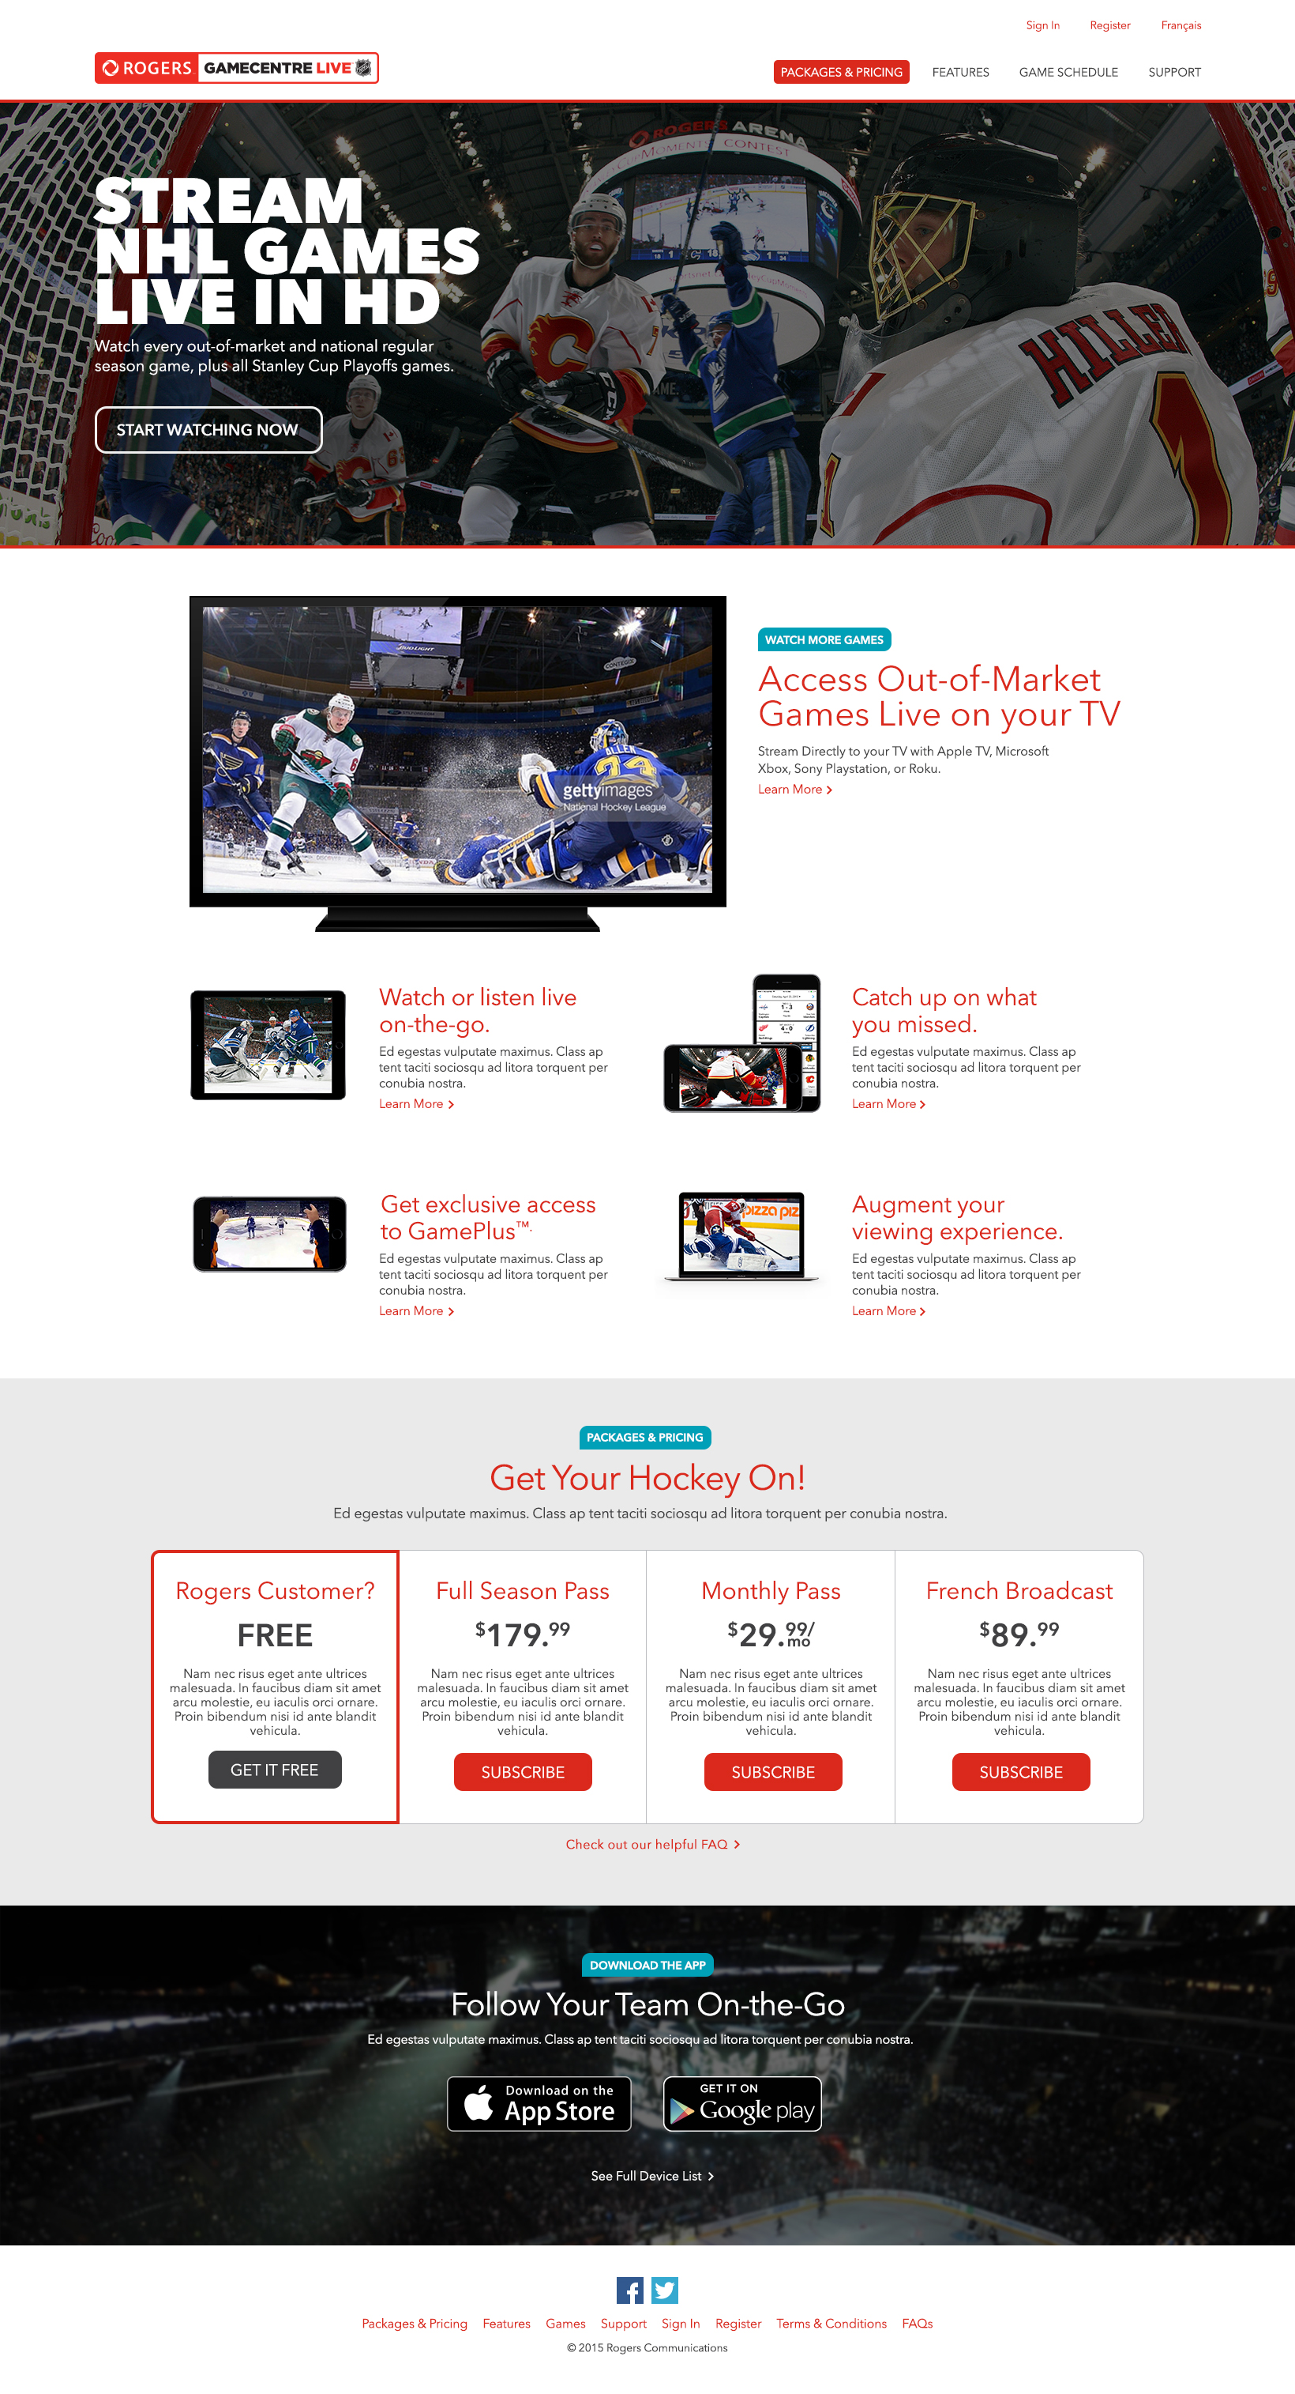

- What is the purpose of this page?

- What options are available to sports fans?

- If you wanted to get this service which one would you choose and why?
(Do you know what cable plan you have? Do you qualify for FREE?)

- What does the App do?

PURCHASE - CREDIT CARD

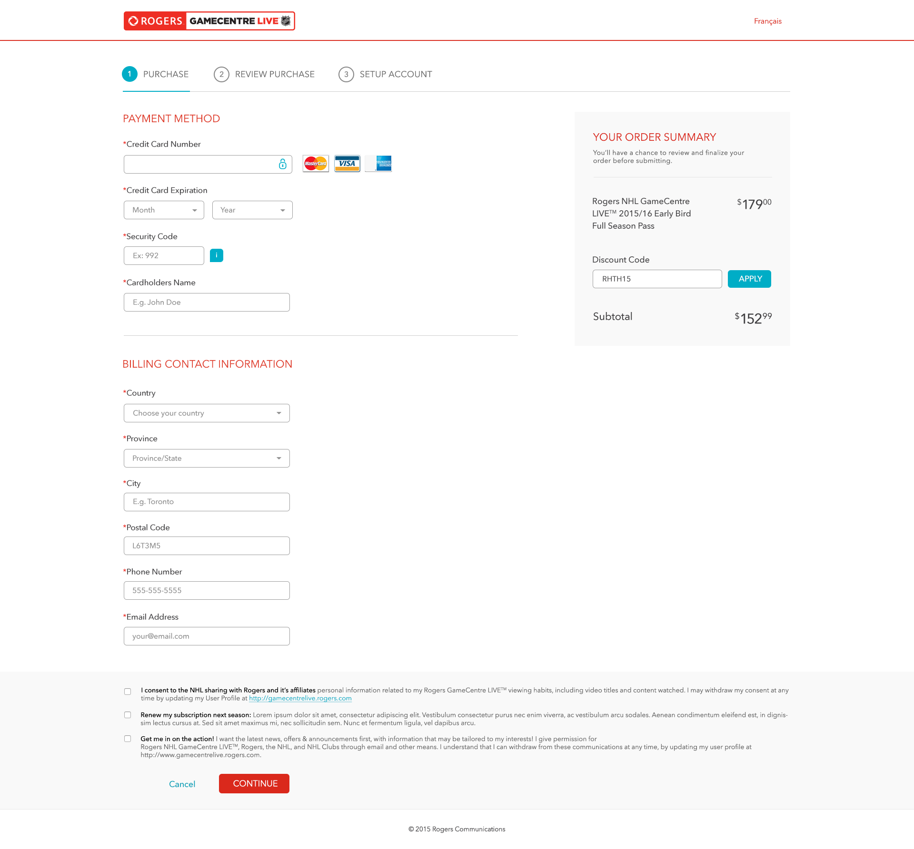

- What would you do now?

Noticed?

- Order summary

- Check Boxes

- Progress bar steps

- Navigation

- Continue button

- How much are you spending/were you going to spend on this?

Order Summary? Easy / not found

BACK? Browser Back / Missing BACK?

- If you wanted to use a promotional offer to save $27 what would you do?

Discount Code

TERMS AND CONDITIONS

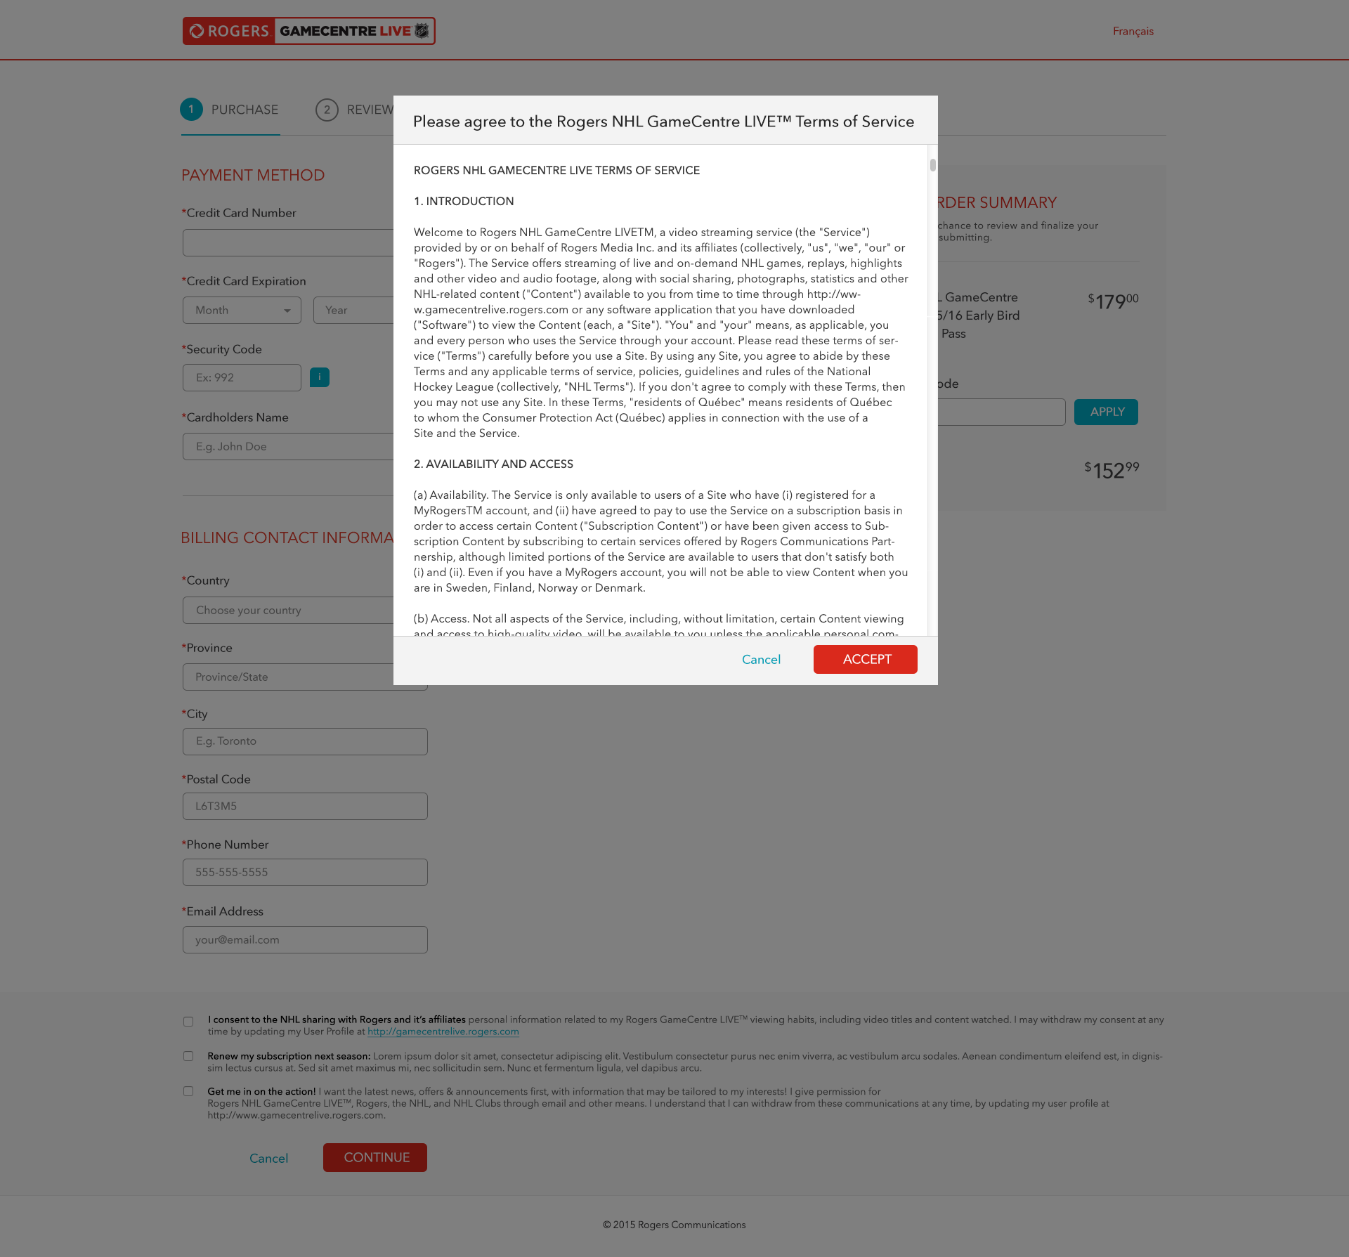

REVIEW PURCHASE

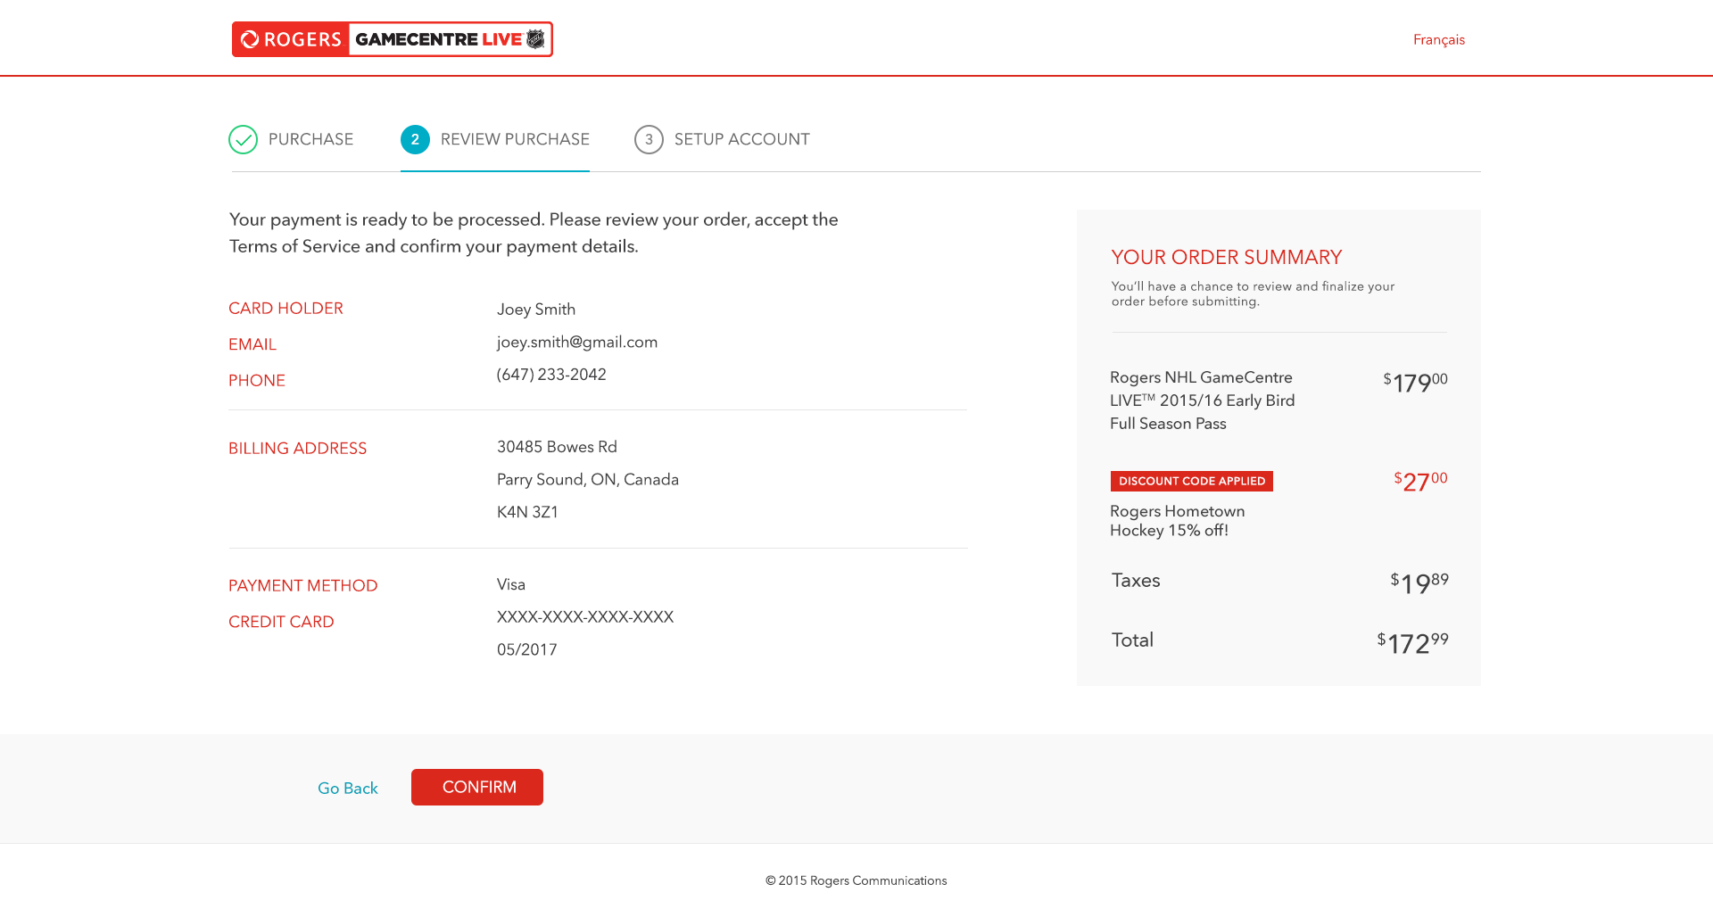

- Any thoughts about this page?

SETUP ACCOUNT - SIGN IN

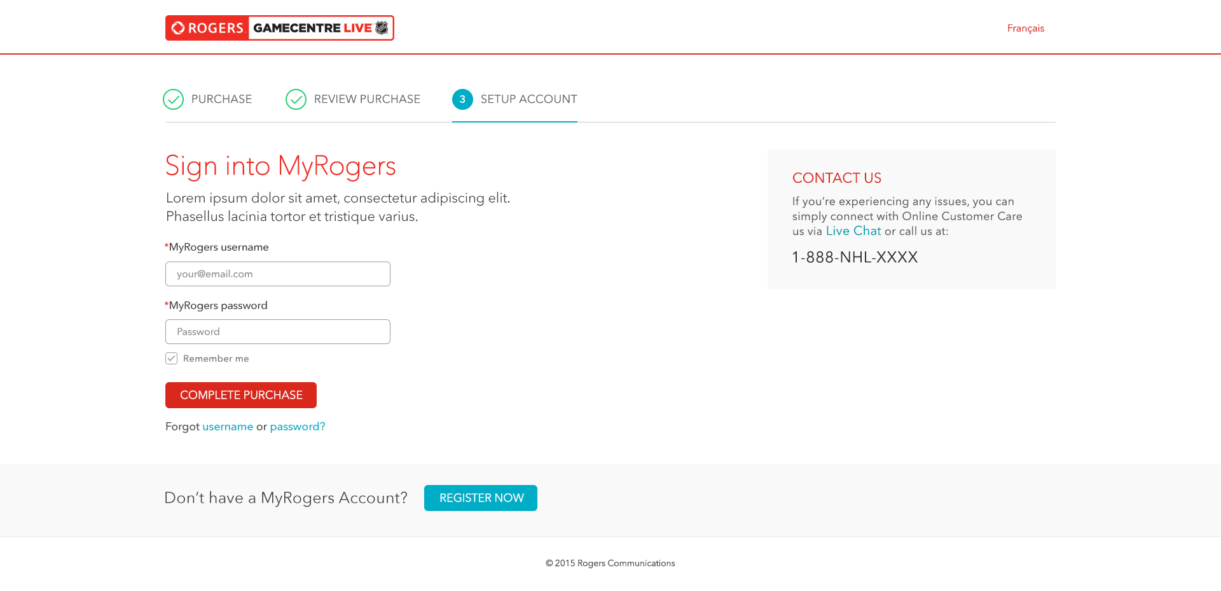

- What would you do now?

- (What do you think about this?)

- Do you know your MyRogers userID & password? Yes / No

- If No what would you do next? Username / Password

SETUP ACCOUNT - REGISTER

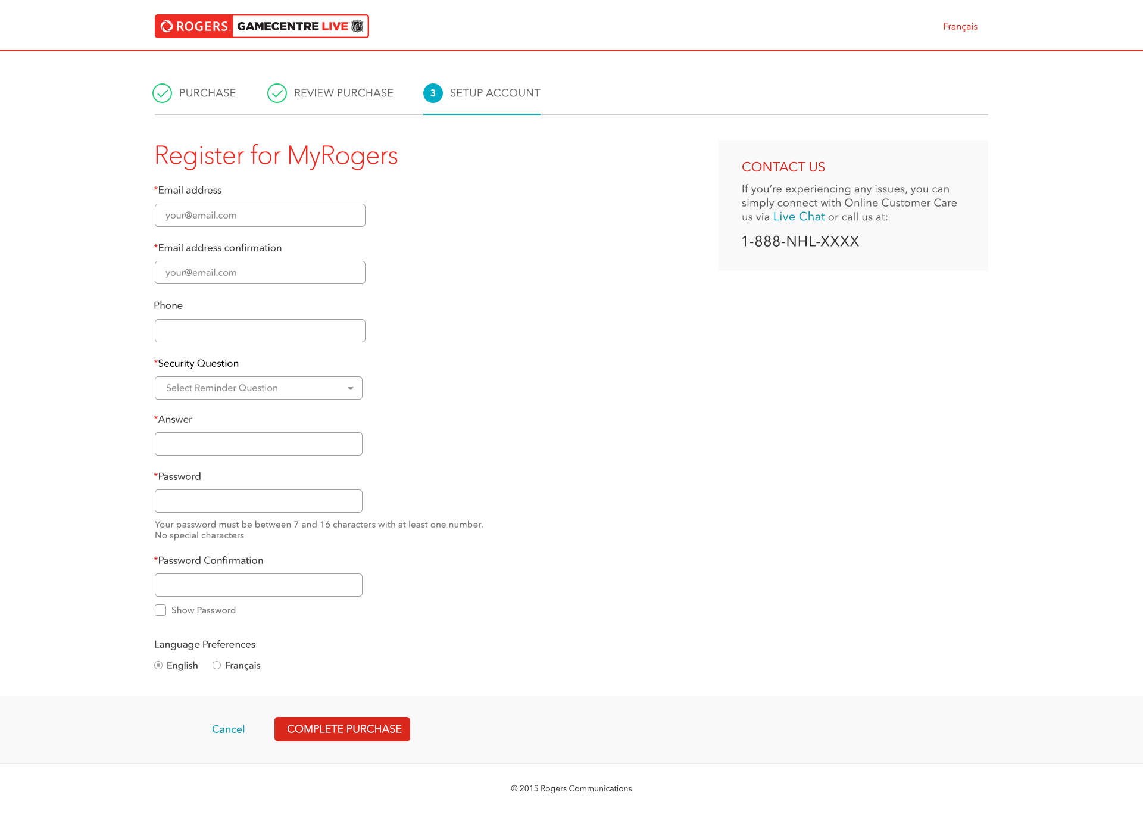

CONGRATULATIONS (PAID)

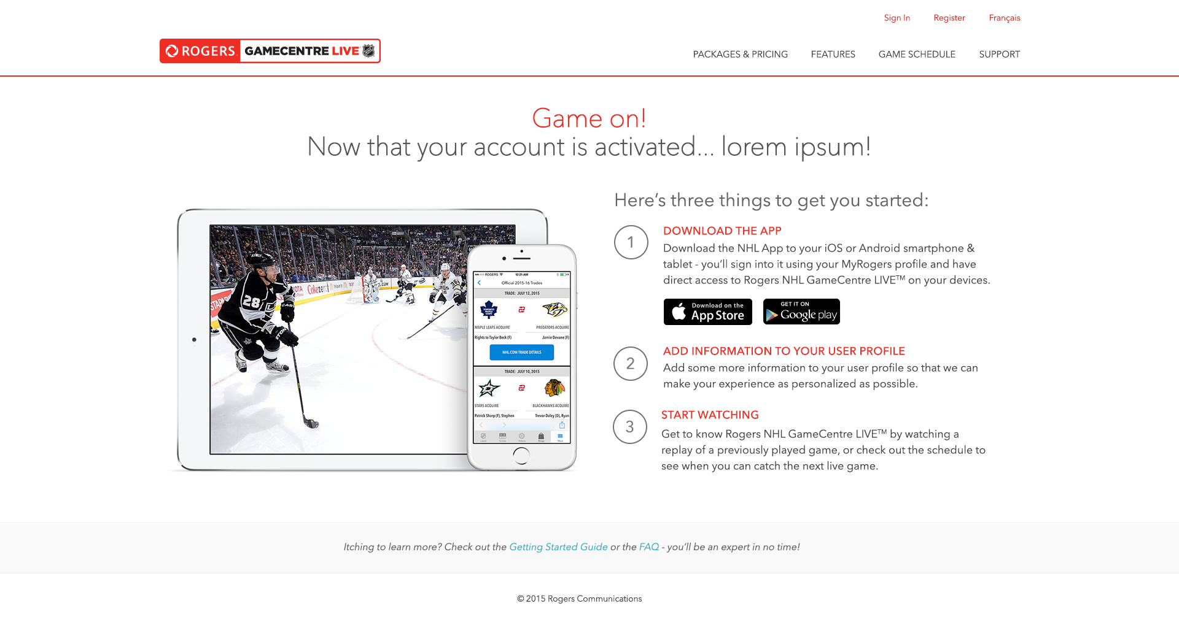

- So what are you thinking?

- What would you do next from here?

CASE B – ELIGIBLE FLOW – FREE

5 Second Test …

- What do you remember seeing on the page?

HOME
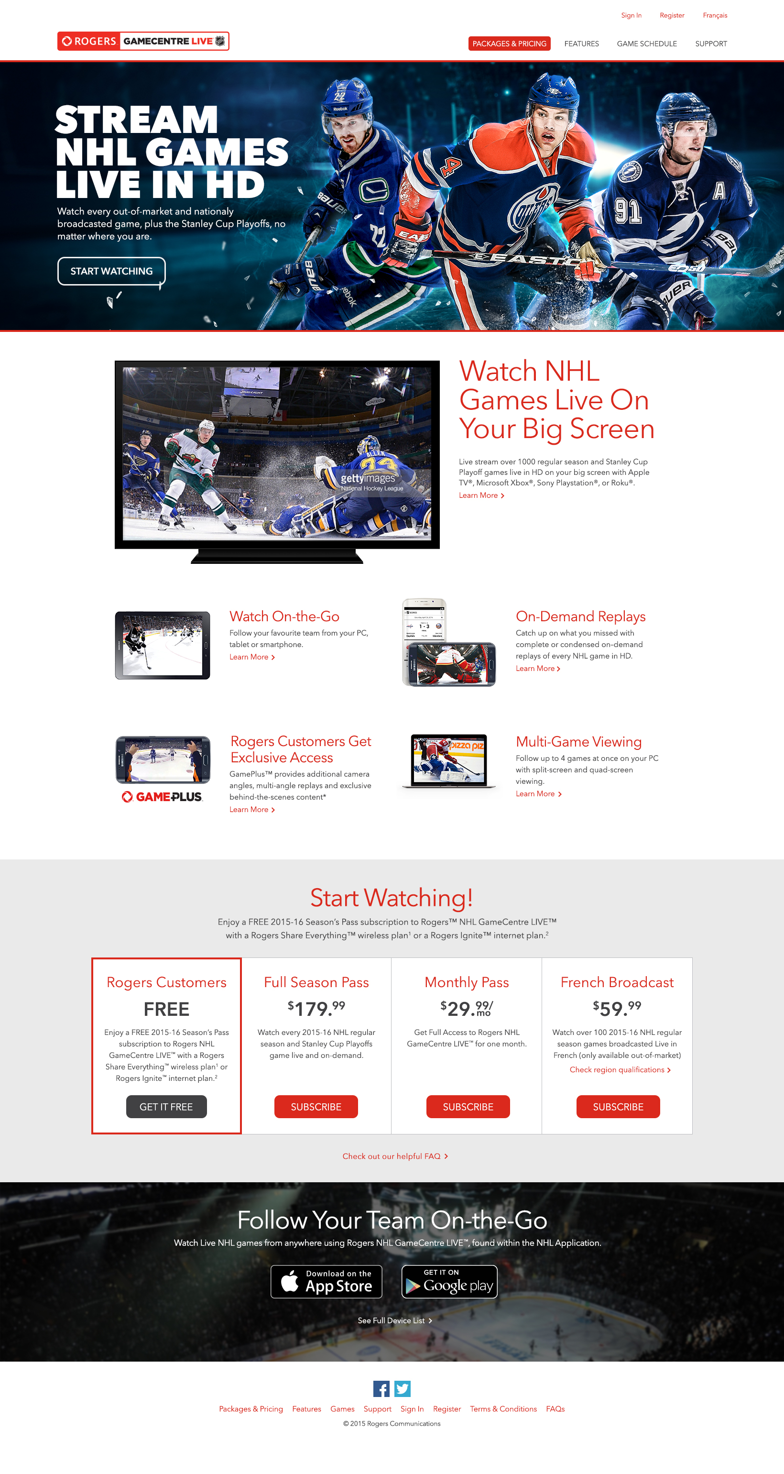

- What is the purpose of this page?

- What options are available to sports fans?

- What does the APP do?

- If you wanted to get this service which one would you choose and why?

SETUP ACCOUNT - SIGN IN

- What would you do now?

- (What do you think about this?)

- Do you know your MyRogers userID & password? Yes / No

- If No what would you do next? Username / Password

SETUP ACCOUNT - REGISTER

SETUP ACCOUNT - ELIGIBLE ACTIVATION PAGE

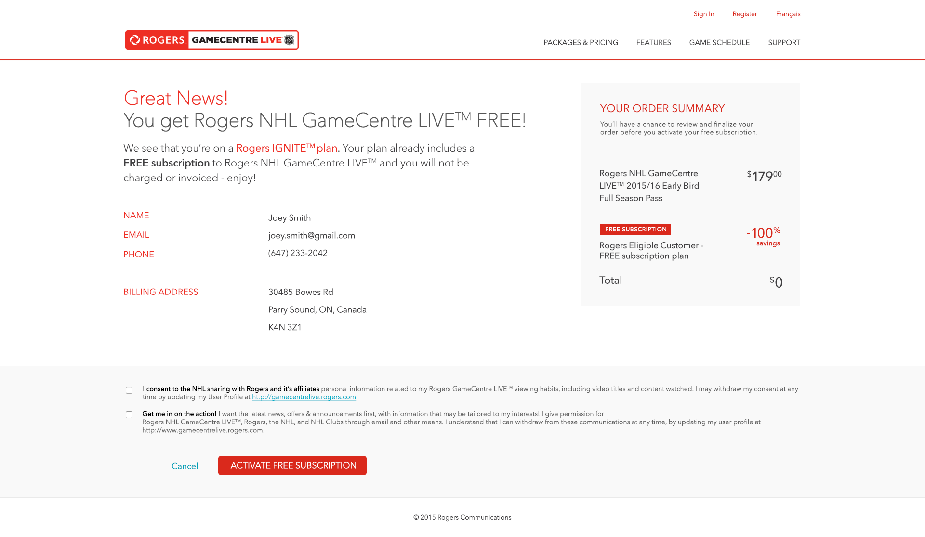

- What does this mean?

Noticed?
- Check boxes
- Order Summary
- Discount Applied

- How much is it going to cost you?

TERMS AND CONDITIONS

CONGRATULATIONS (ELIGIBLE – FREE)

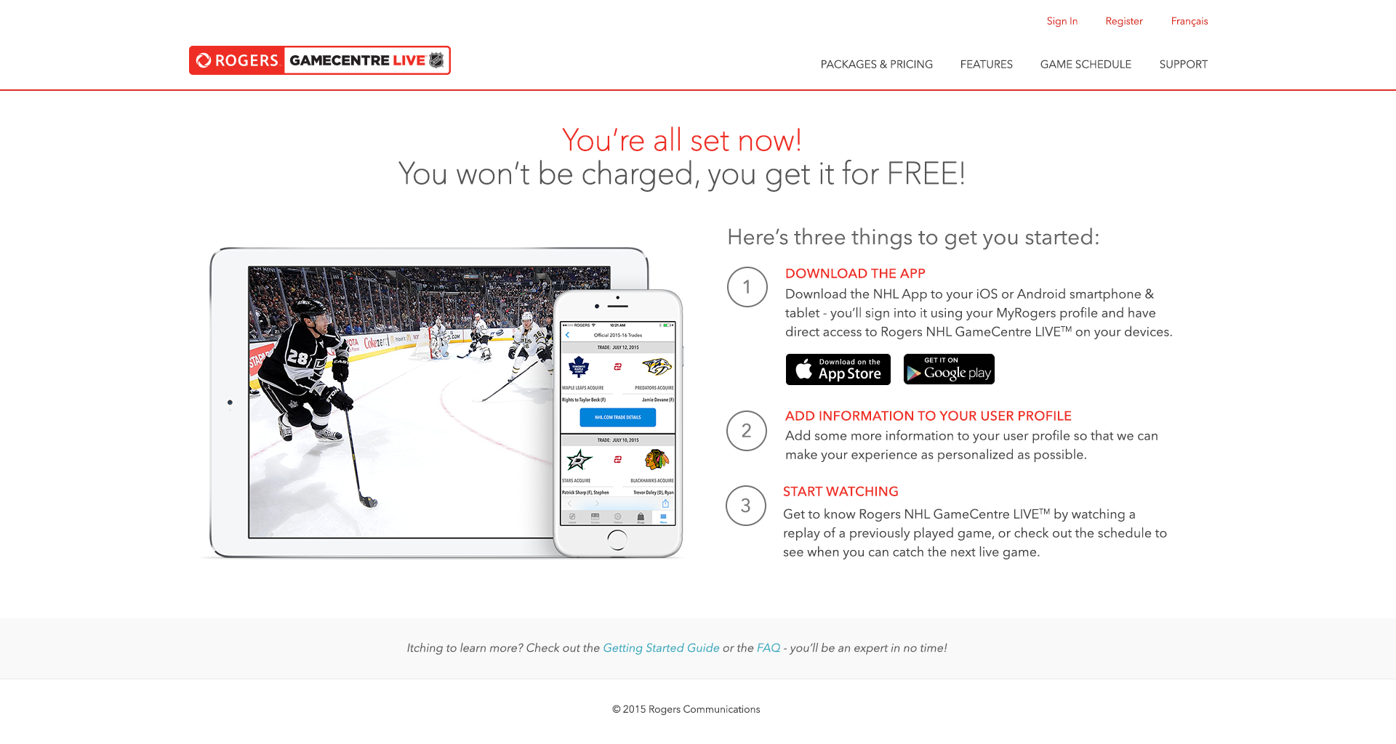

CASE C – INELIGIBLE FLOW – FREE

5 Second Test …

- What do you remember seeing on the page?

HOMEPAGE

- What is the purpose of this page?

- What options are available to sports fans?

- What does the APP do?

- If you wanted to get this service which one would you choose and why?

SIGN IN

- What would you do now?

- (What do you think about this?)

- Do you know your MyRogers userID & password? Yes / No

- If No what would you do next? Username / Password

REGISTER

INELIGIBLE PAGE

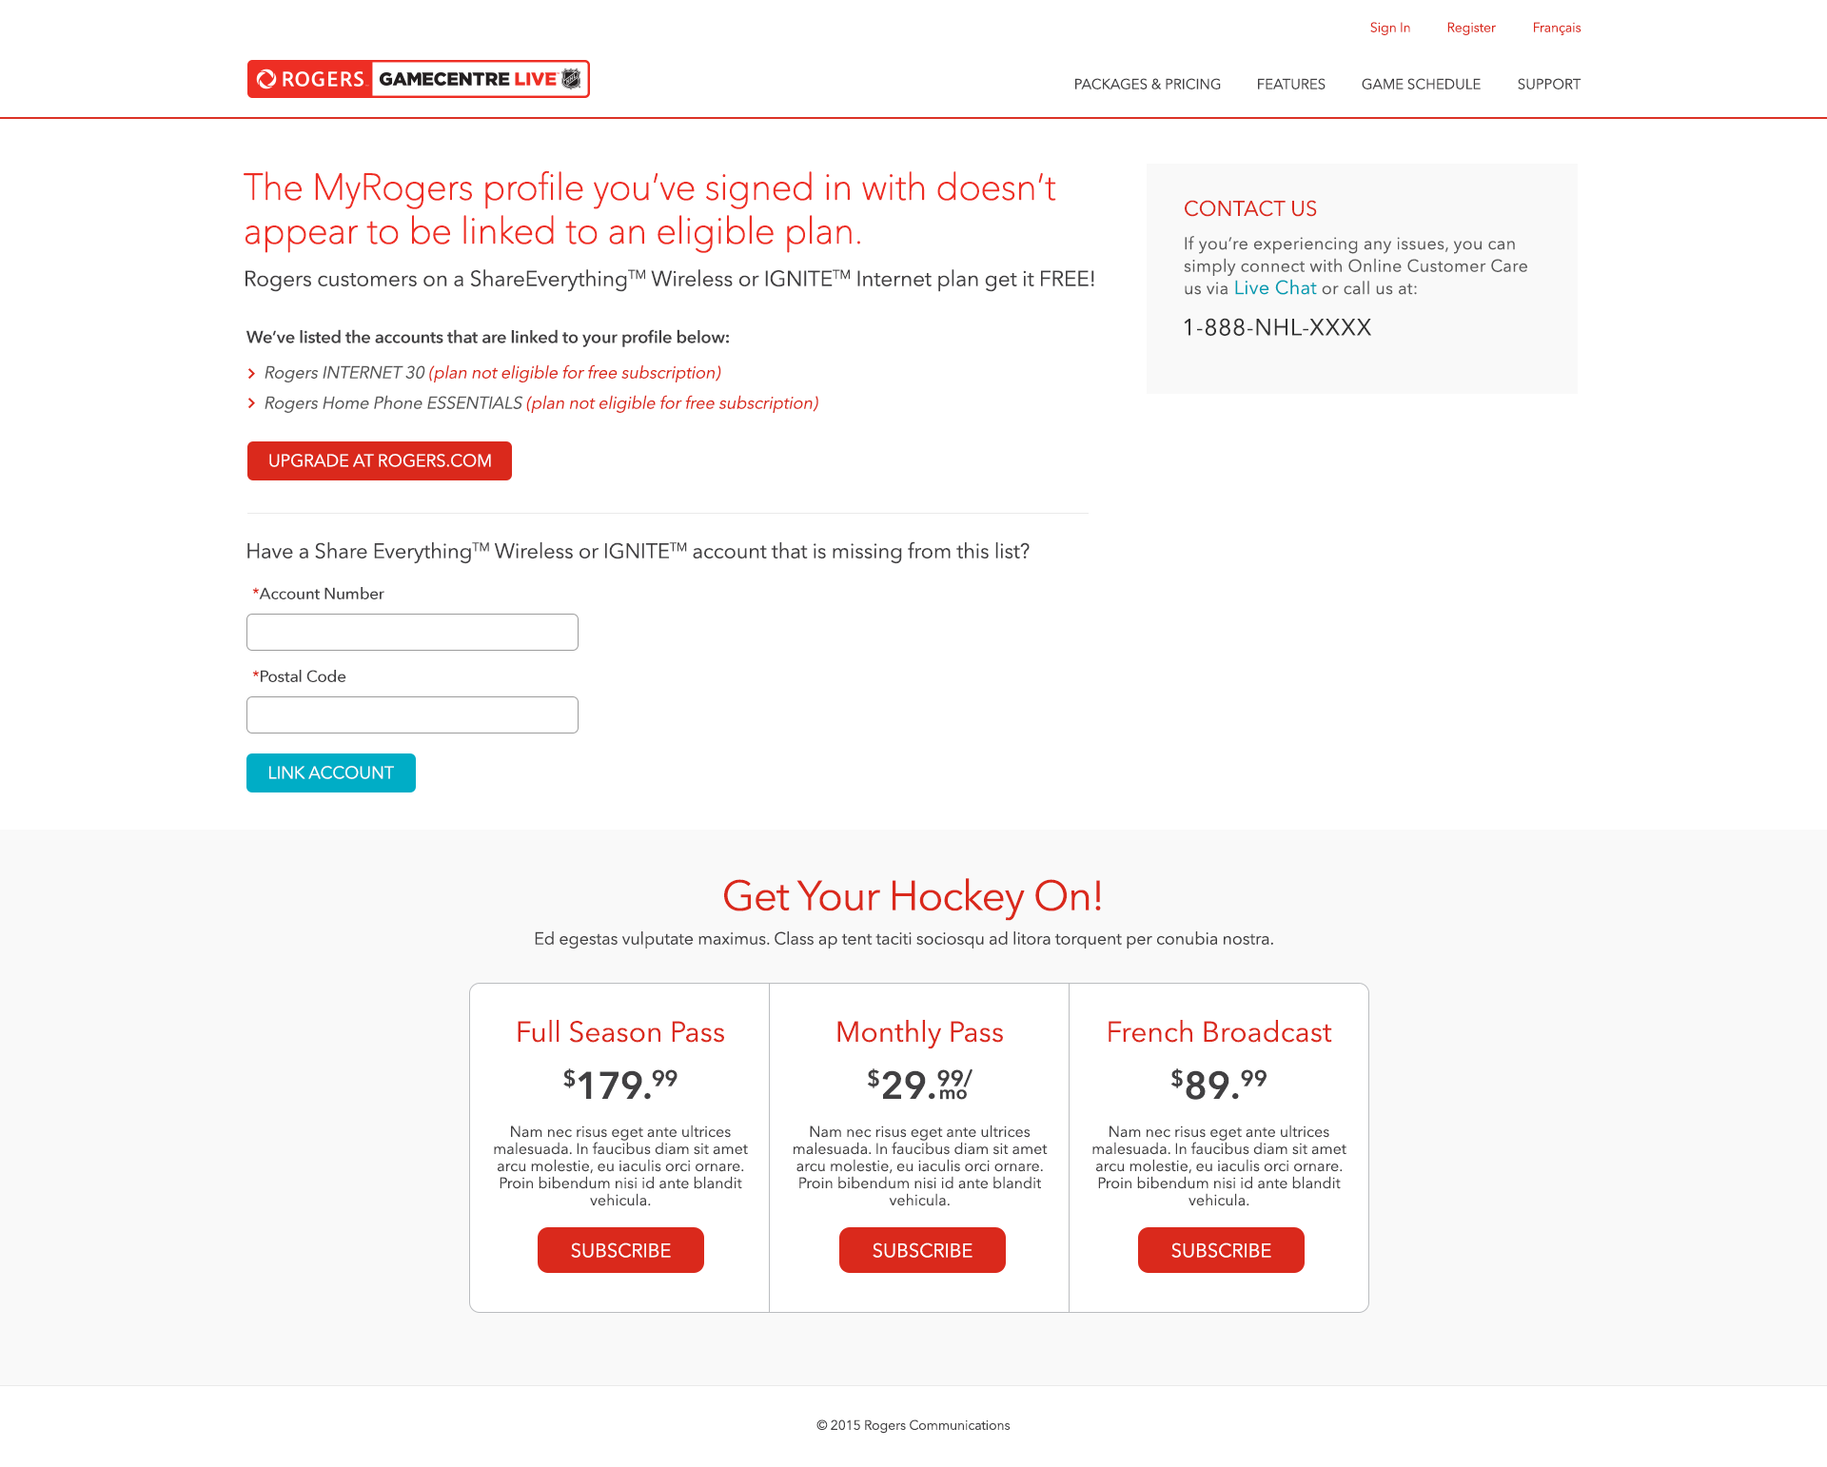
- What do you feel you should do on this page?

- Where would you go to link an eligible account?

